DETECTO -OBJECT DETECTION:

[Detecto](https://github.com/alankbi/detecto) is a Python package that allows you to build fully-functioning computer vision and object detection models with just 5 lines of code. Inference on still images and videos, transfer learning on custom datasets, and serialization of models to files are just a few of Detecto’s features. Detecto is also built on top of PyTorch, allowing an easy transfer of models between the two libraries.

ABOUT THE PROJECT:

USING THE DETECTO package detected the animals for 3 classes as tiger elephant and panda Here the step begins with object collection

Note : As the detecto is a package built on top of pytroch with TensorFlow took lot of time for training as because of my laptop configuration was not that much high as only I have chosen 3 class images for animal detection

STEP 1:

OBJECT DATA SET COLLECTION

Here is the data set for the three animals I have collected as follows

Remember you should have atleast 75 images in each class

|  |  |
| --- | --- |
|  |  |

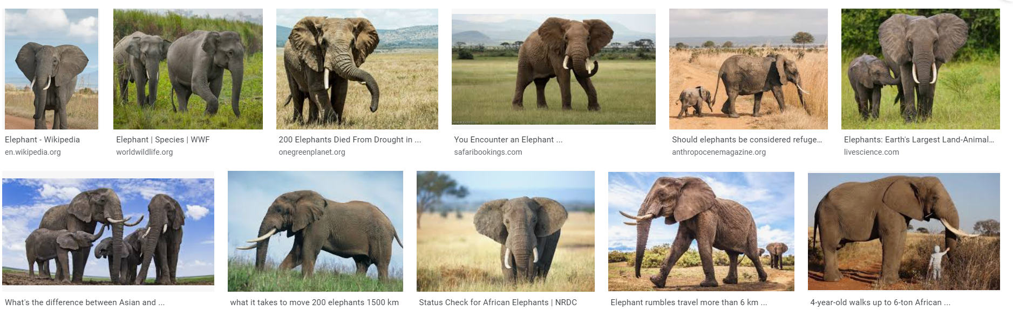

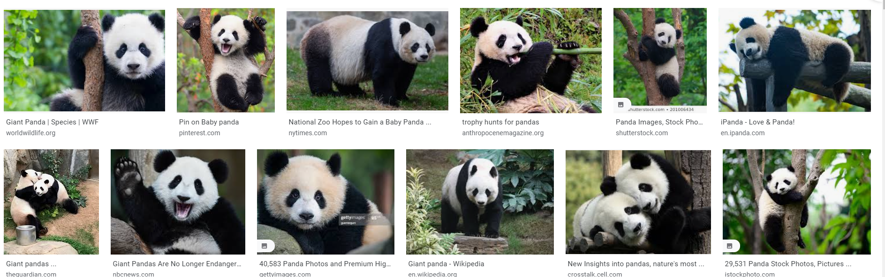

Here by downloading the images 75 for each class as tiger elephant and pandas from google. I have used the **download all images** extension to download the bulk amount of images as the extensions shown below as

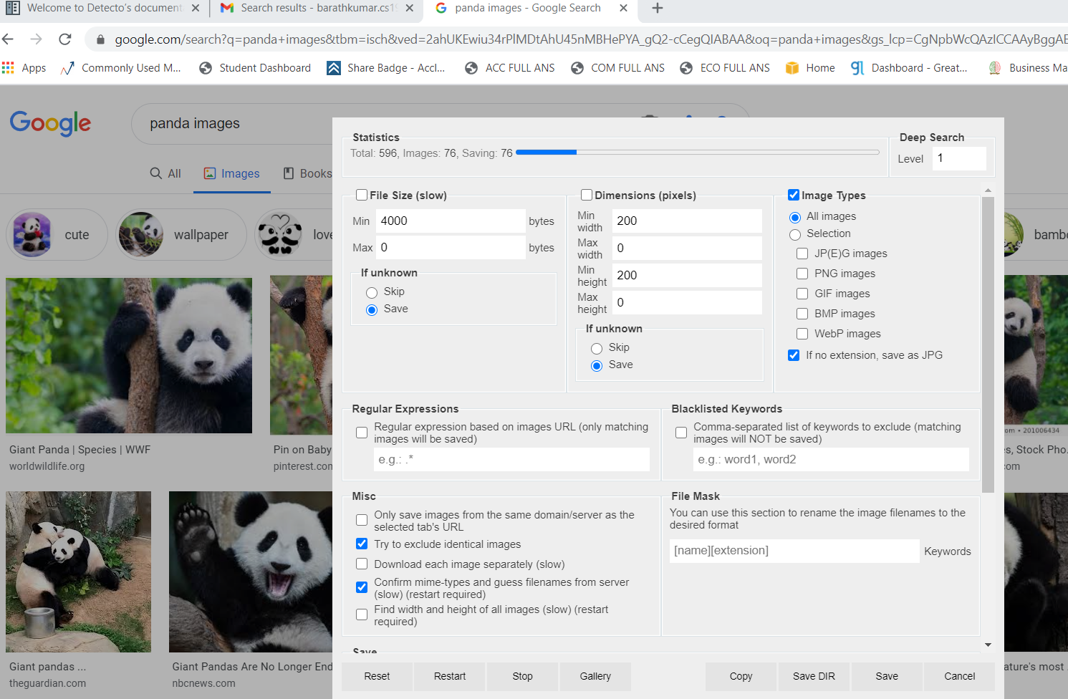

Save all the images in single folder and name it (for example: images)

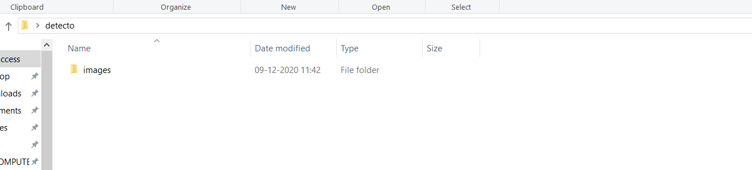

STEP 2:

Selecting and labelling the images

The next step involves to read the image in the xml format for training it with some specific algorithm as the Software called **Labellmg** which is available open source to convert the images with respect to the xml file.

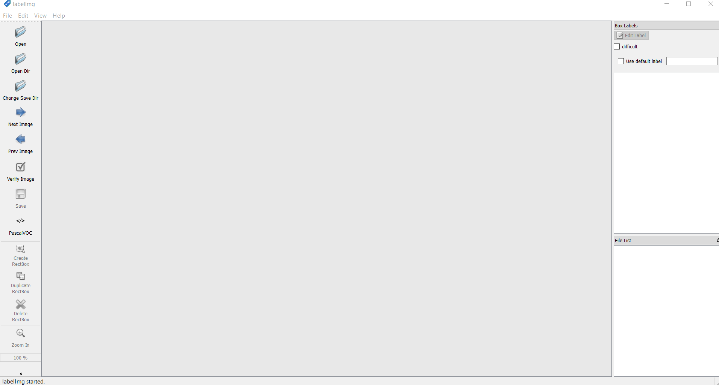

Here select the open dir to open the folder that the images have been downloaded as the data set

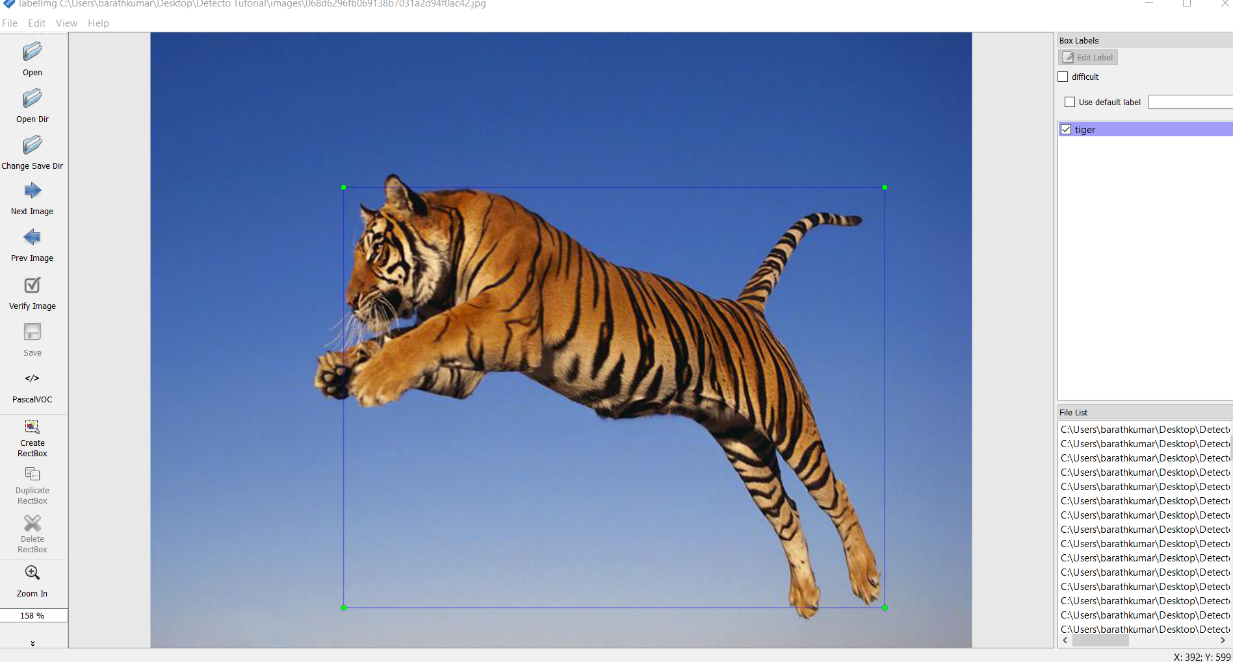

Now click the Create Read box option to draw a box where the animal is exactly on and classify them it prompts to save the xml file to be saves click save to proceed further

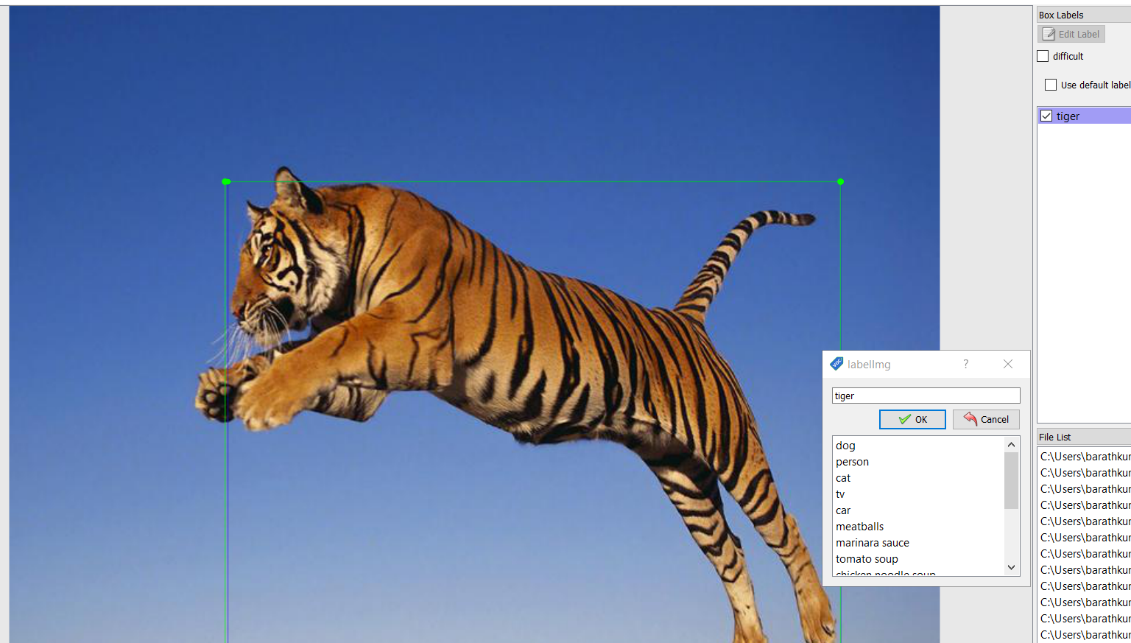

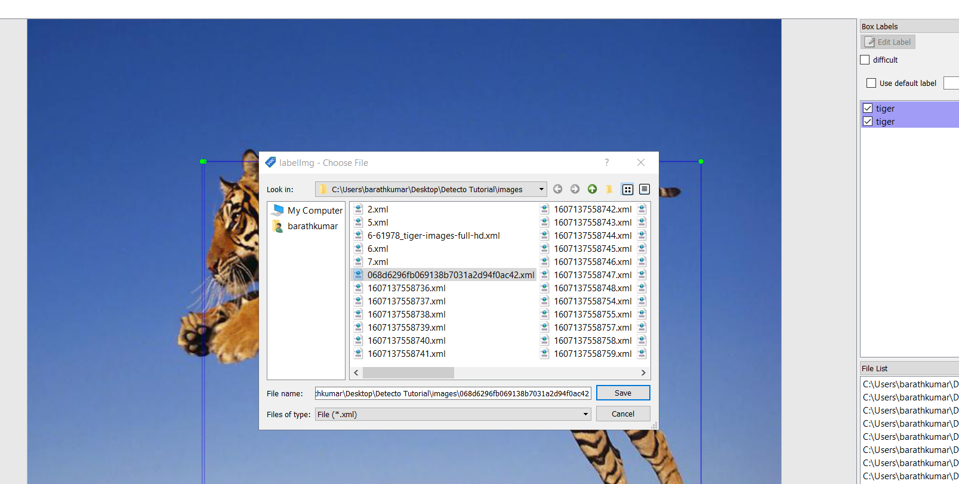

Click save to proceed and repeat it for all images the xml file will be saved on the images folder one by one in order

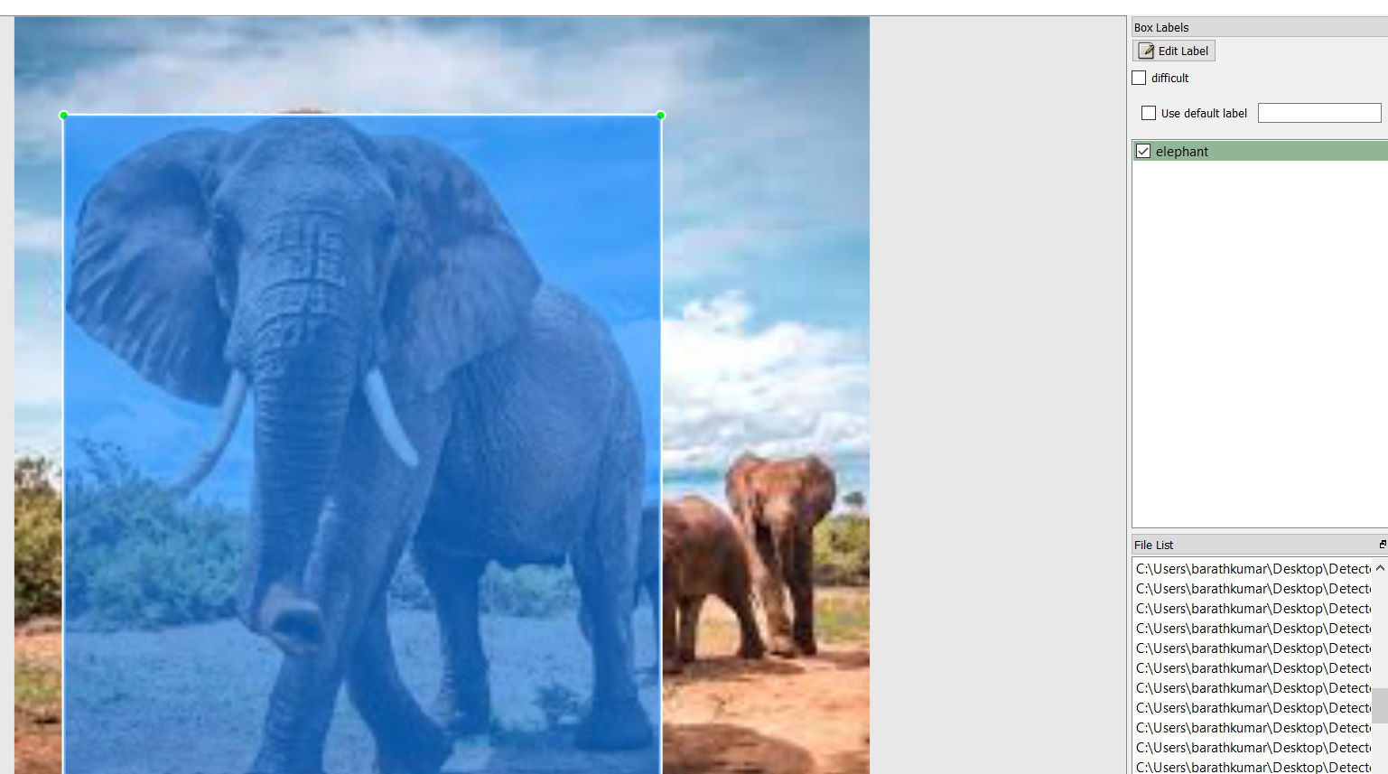

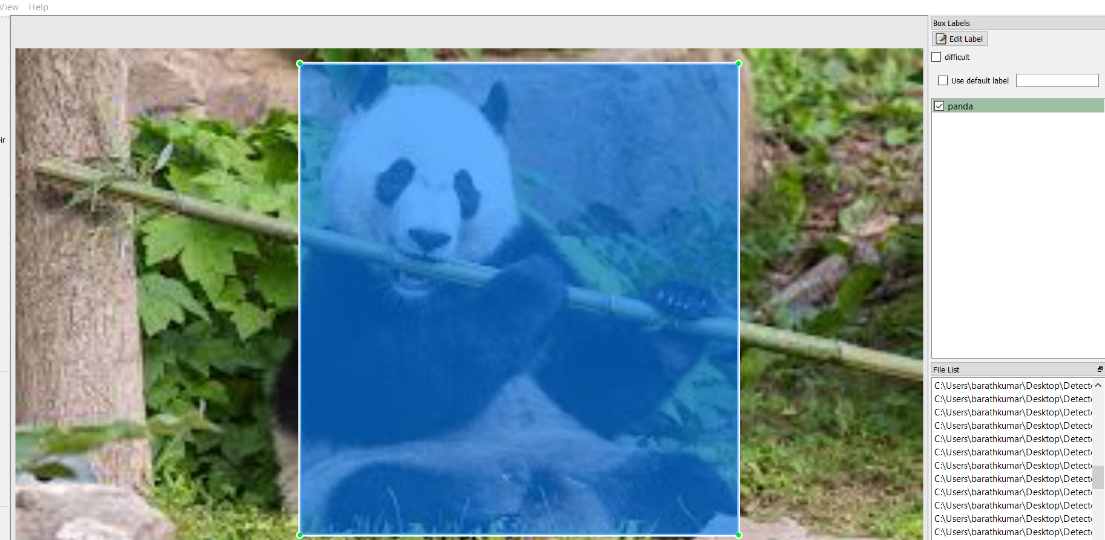

NOTE: You can also classify the images from the single picture itself (for example – a single picture can consist of tiger, elephant and panda can be classified)

The created Xml file stored with next to respective location where images found

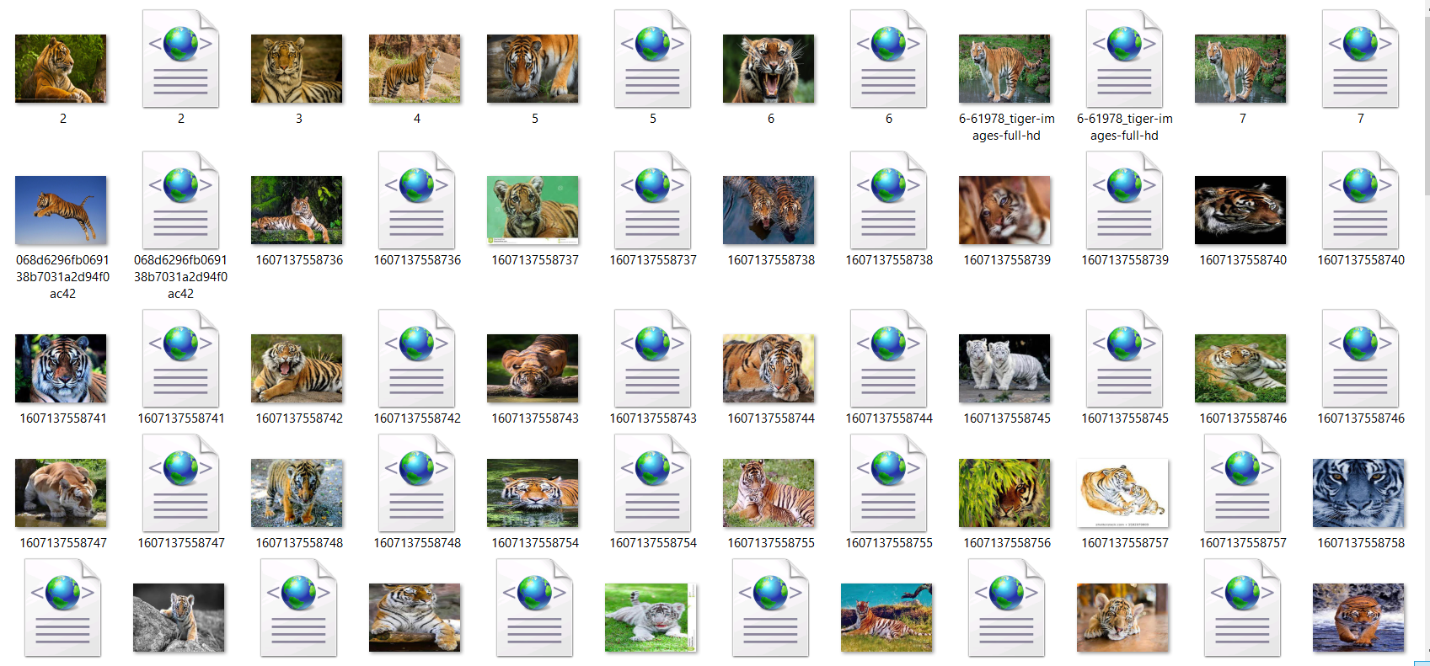

The xml file consists of image details as its height, weightage, depth position placed etc. as below

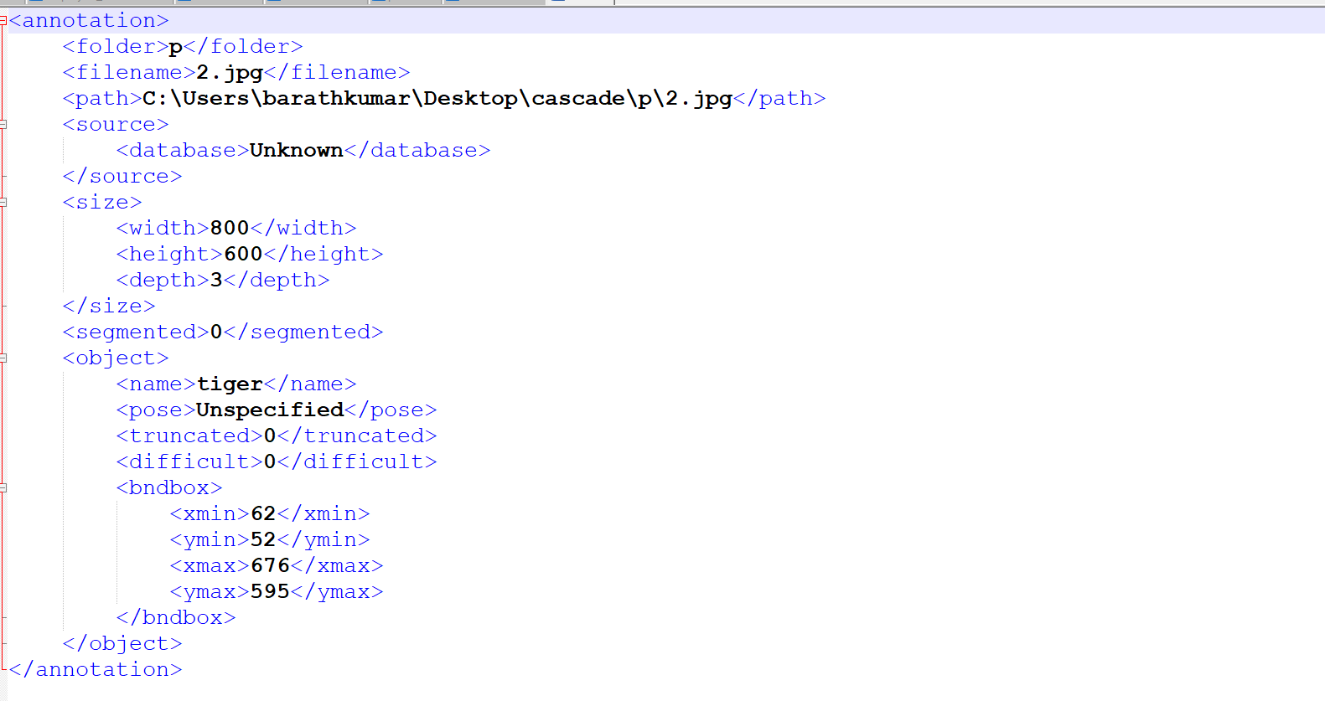

Step 3

SETUP DETECTO WITH PYTHON AND WORKING

I am using anaconda for this as it follows to install do pip in Anaconda prompt to install Detecto package (or) You can also use Google colab for this if you have no GPU in your computer specified as the pytorch needs gpu to process the images



Now all is set let’s work on jupyter notebook further

Open the ipynb file where you have saved the images folder

First import the detecto package then save the images (the image dataset with xml files) to the variable Give the class to be in the images to be detected and finally train the model. It will take some time to train the model

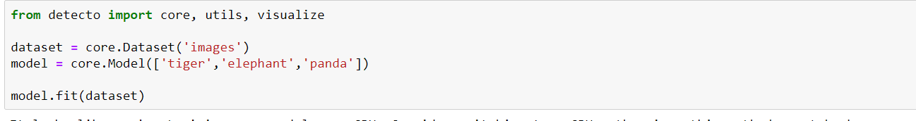

Now testing the model with a image

Here is the image Which is not used in training the images with tiger and elephant now can see whether it predicts correctly



This is following code to detect the image

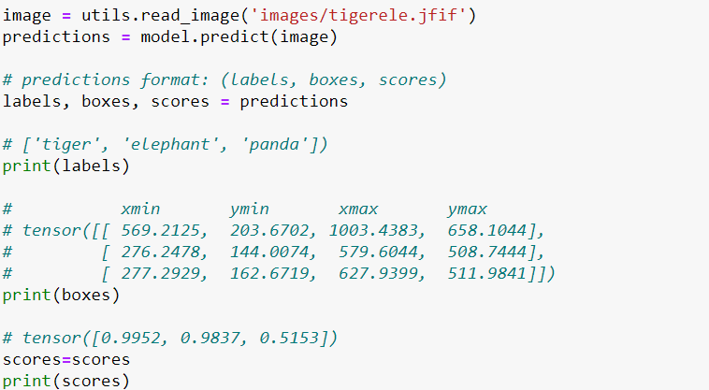

Here the read_image function reads the image stores in image variable the predict function =returns the values in 3 format respectively labels as no of class got from the image boxes as the coordinates the object detected and finally score is confidence score of the image whether it is prese t in that image. The output will be

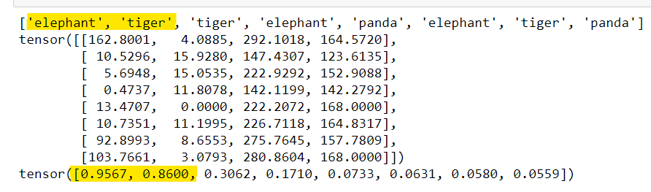

As you can see the prediction results had correctly predicted the noisy of repeating the class due the low no of images used for training also the background noise present in the image but we got the correct results as the first list tells the class present in the image the tensor tells the coordinates predicted with object at last the tensor tuple consists of confidence level score as when it is higher then 0.75 the possibility of presence of image is high in it. For the above image it is correctly predicted.

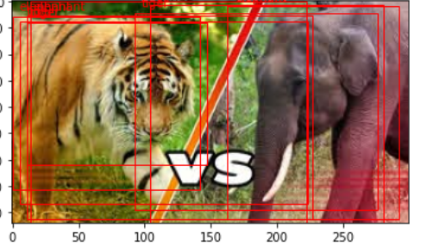

Saving the model as the file and using later can be done it will help you when reuse of the object detection whenever is possible

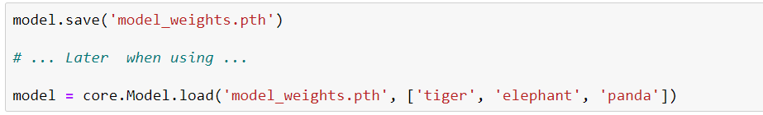

The first command saves the model as the pth file in your local system The second command is used when it is reused again for the use.